Meghan Ng

Geog 360

Tutorial 4: Simply Seattle

28 October 2016

**1.**

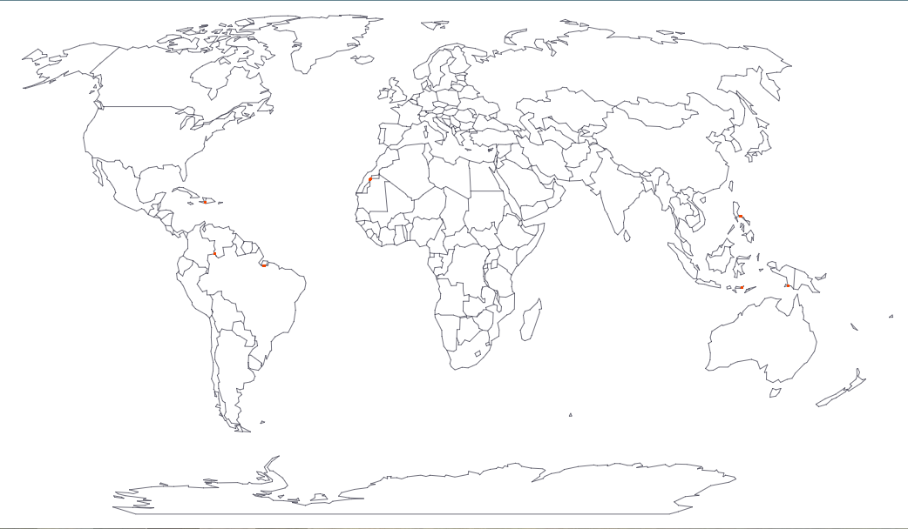

I chose the Visvalingam / effective area method for the choropleth map of national literacy rates because the higher latitude areas are not as distracting as the ones on the Douglas-Peucker method, and not as simple and unrecognizable as the ones on the Visvalingam / weight area method (many islands as well as the long tail of Alaska were missing).

**2.** My blank Seattle Atlas page

<http://fieldpapers.org/atlases/118878>

**3.**

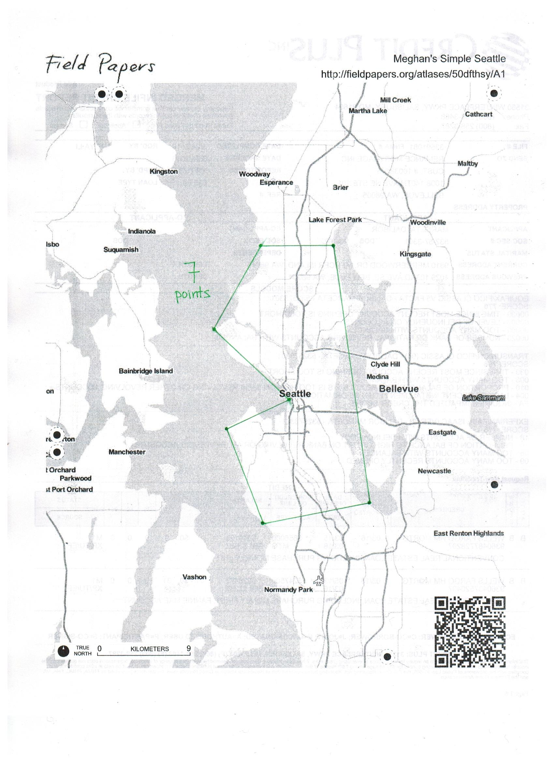

**4.** Tile Service URL

<http://tiles.fieldpapers.org/snapshots/3pkqjrl3/$z/$x/$y.png>

**5.**

